**Homevisits EMIS Web Training Hand Out**

[TEXT……………………………….]

**GP Practice**

* Go to ***Find cross-organisational appointments***
* Click on ***Homevisit*** in slot properties

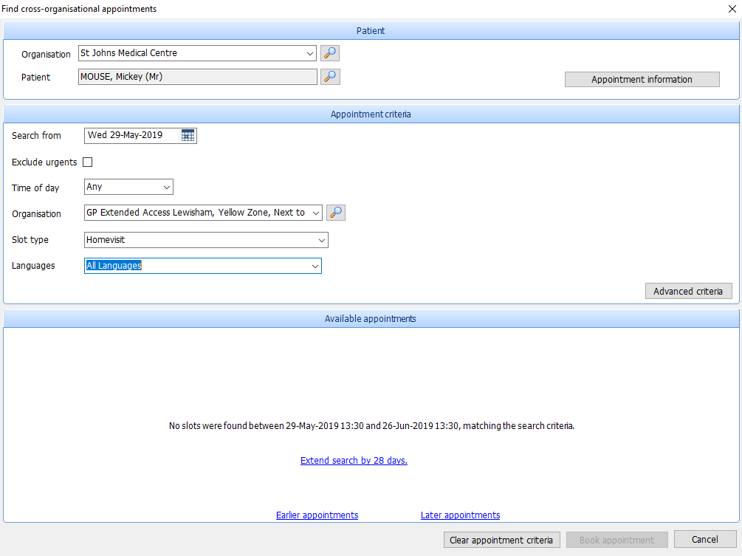

**GP Practice**

* Add reason
* Booking notes: ***Add any relivent additional informaion i.e carer name & a contact number***

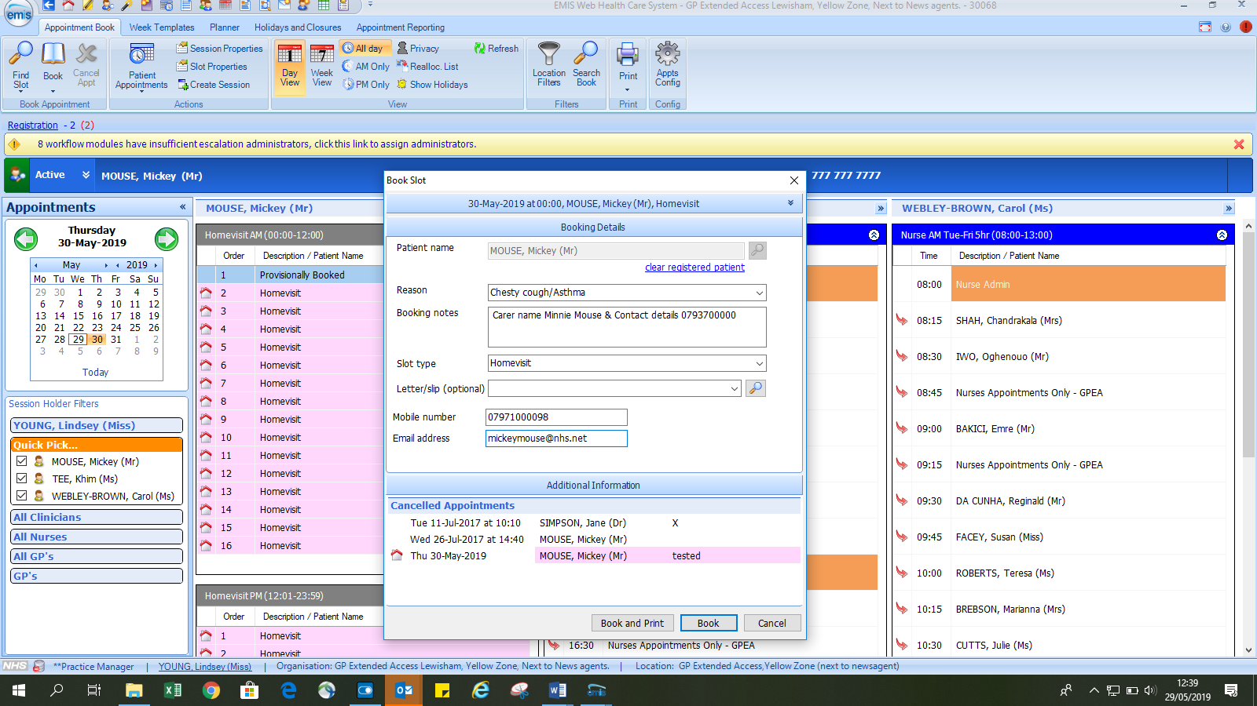

**GPEA**

List of Patients booked for homevisits

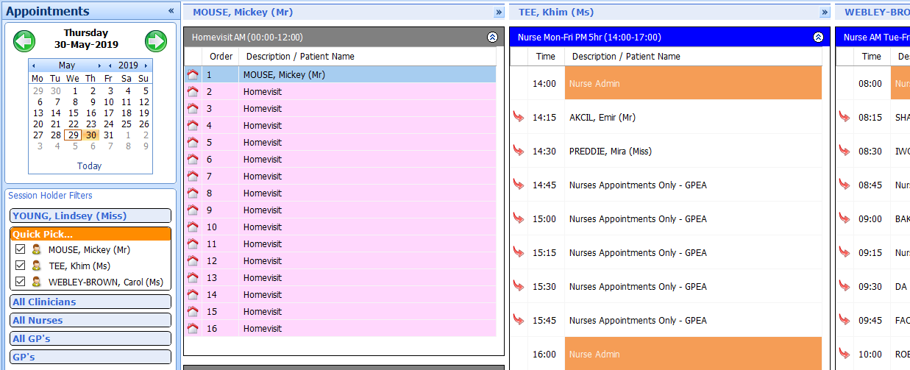

**GPEA**

Homevisits information

* Right click on patient
* Add comment after slot

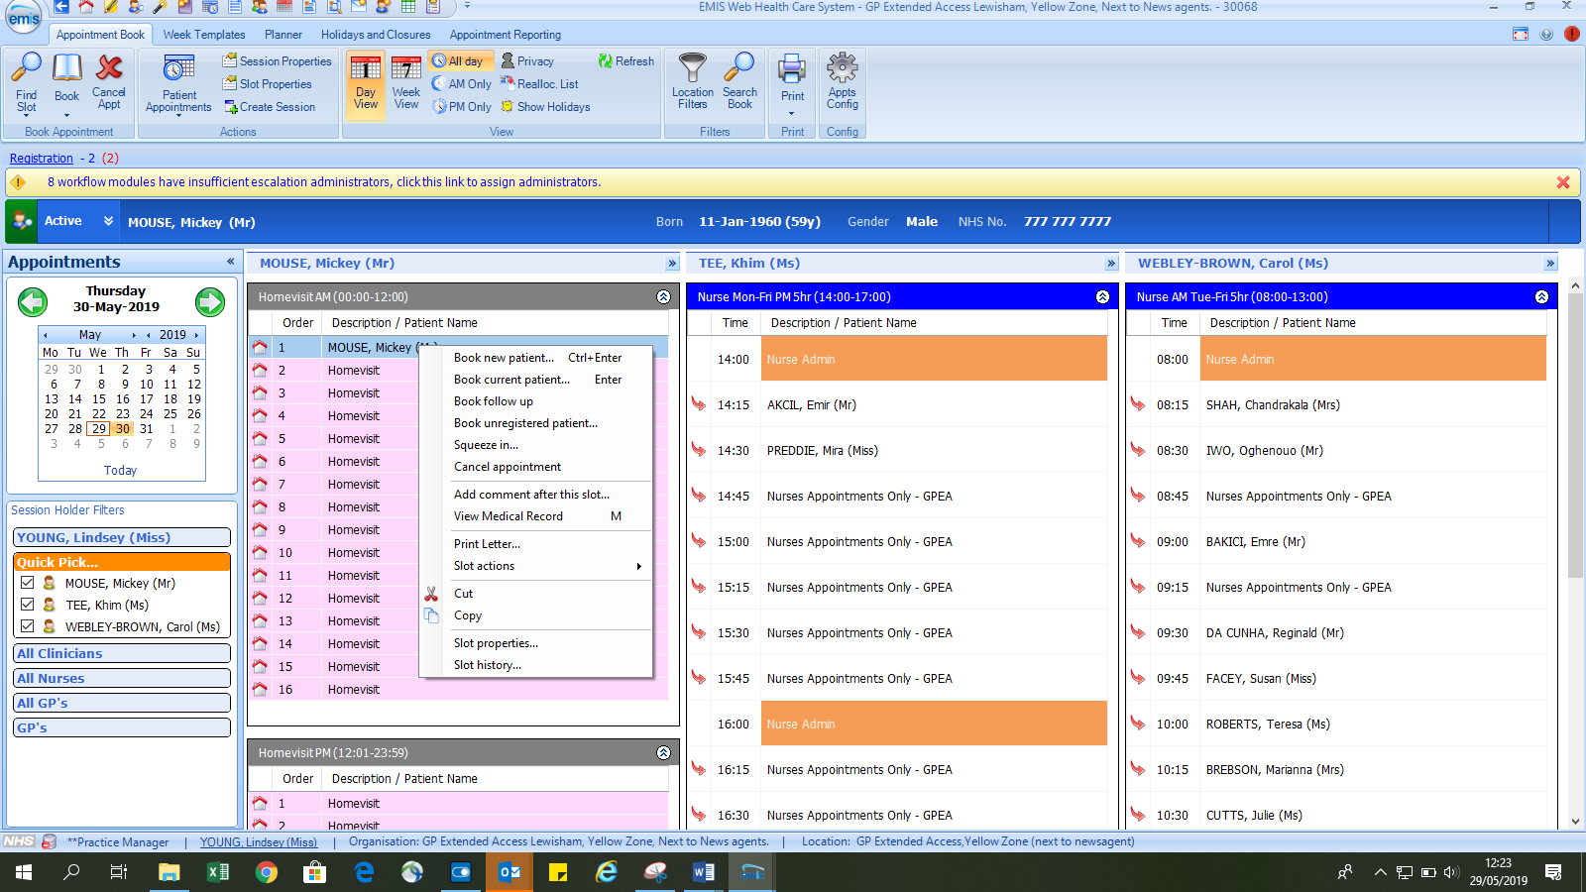

**GPEA**

* Enter comment - ADD name of GP to visit and time of visit

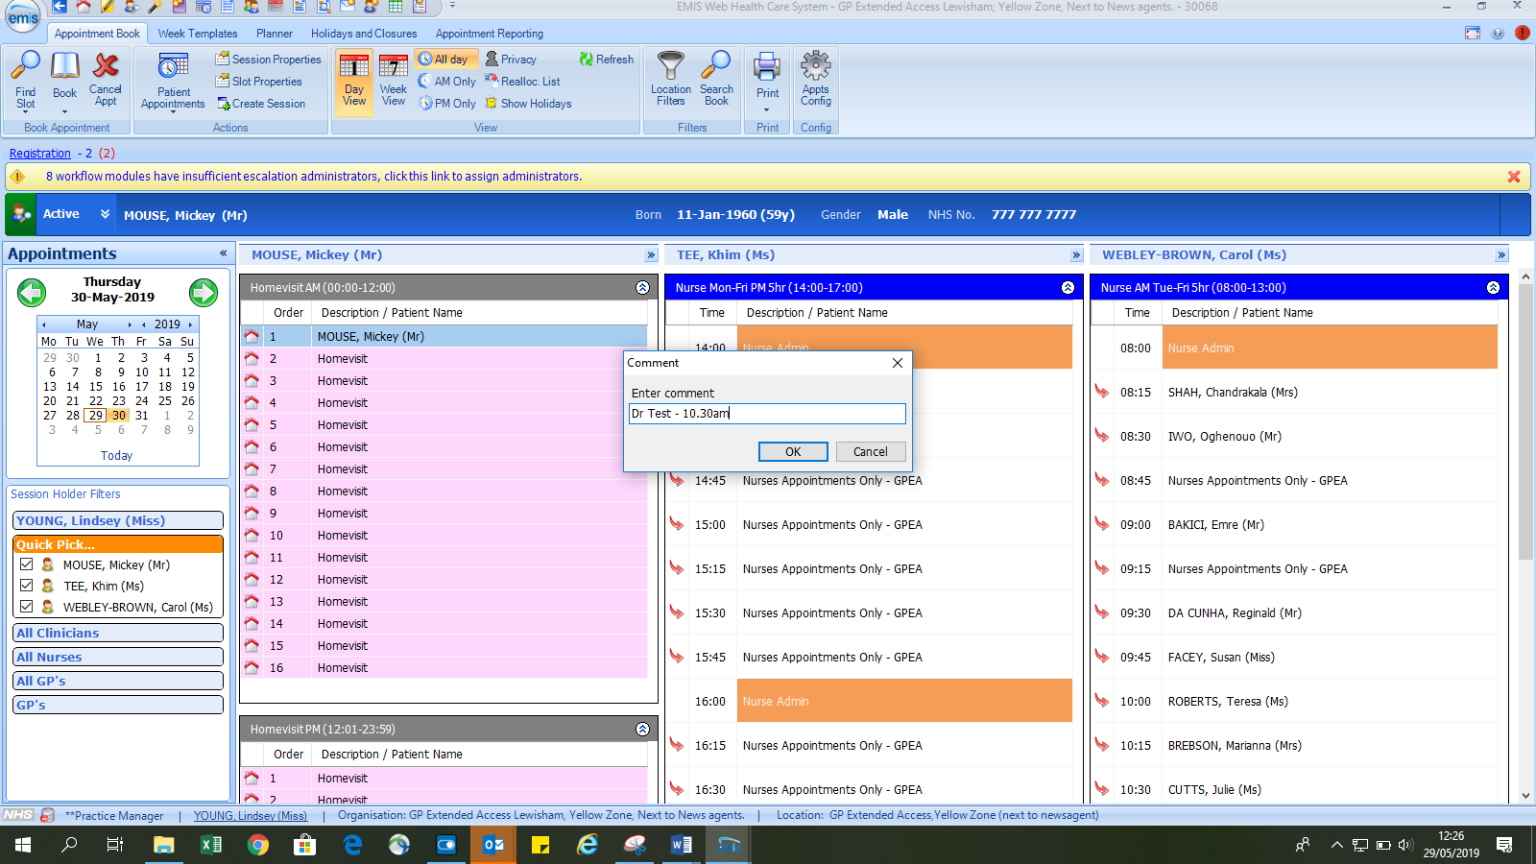

**GPEA**

* List of Patients booked for homevisits

